EDIFY E-LEARNING PROJECT
BABY CLASS END OF PROGRAM ASSESSMENT
SUBJECT: WRITING
DURATION: 1 hour
My name is_______________________
1. Write a standing line and a sleeping line
l | __ | l | __ | l
2. Write a front curve and a back curve

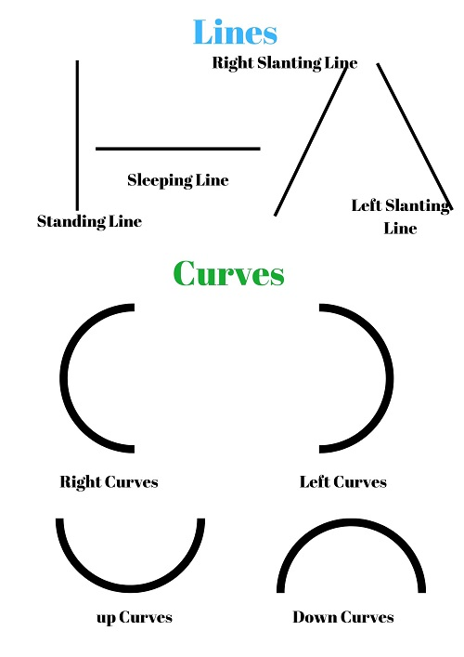

Good luck!

